WORD EMBEDDING TECHNIQUES---word 2 vec( skipgram / cbow) / glove
WORD 2 VEC / GLOVE

WORD EMBEDDING----FEATURE WISE REPRESENTATION
words that are close in meaning are grouped near to one another in vector space. For example, while representing a word such as frog, the nearest neighbour of a frog would be frogs, toads, Litoria.
king nad queen went to palace

if i am geeting x and y fo queen and king then can i represent the data in vector form
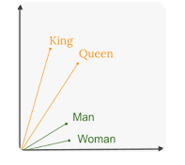

Word Embedding or Word Vector is a numeric vector input that represents a word in a lower-dimensional space. It allows words with similar meaning to have a similar representation. They can also approximate meaning. A word vector with 50 values can represent 50 unique features.
Features: Anything that relates words to one another. Eg: Age, Sports, Fitness, Employed etc. Each word vector has values corresponding to these features.
Goal of Word Embeddings
- To reduce dimensionality
- To use a word to predict the words around it

Word embedding is the collective name for a set of language modeling and feature learning techniques where words or phrases from the vocabulary are mapped to vectors of real numbers. The technique is primarily used with Neural Network Models.
Conceptually it involves projecting a word from a dimension equivalent to the vocabulary length to a lower dimensional space, with the idea being that similar words will be projected closer to each other.
For the sake of understanding we can think of embeddings as each word being projected to a space of characteristics as shown in the image below.
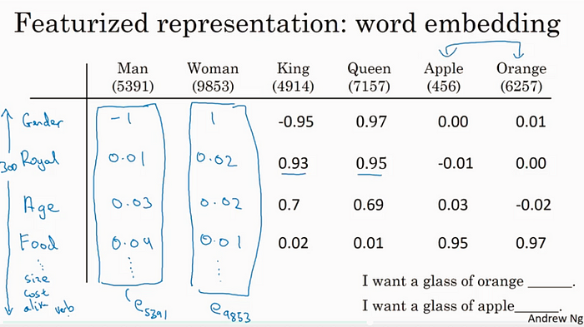
Image credit : Andrew Ng, Coursera. Each word being represented in a space of characteristics (Gender, Royal, Age, Food) etc
However, in reality these dimensions are not that clear or easily understandable. This does not concur a problem as the algorithms train on the mathematical relationships between the dimensions. What is represented by the dimension is meaningless for a neural network from training and prediction point of view.

with one hot encoding we can convert into variable
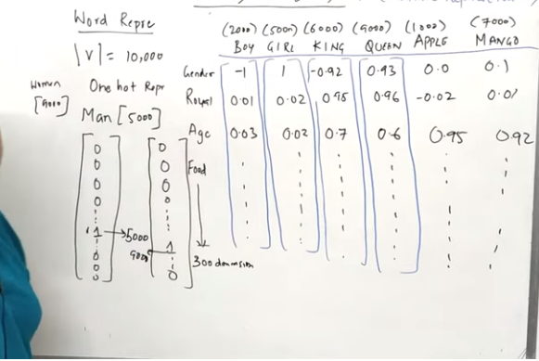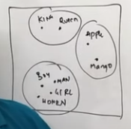
LOw dimension / dense matrix

WORD 2 VEC -Skip-gram and Continuous Bag of Words (CBOW).

WORD 2 VEC-------Word2vec is one of the most popular implementations of word embedding. It is used to create a distributed representation of words into numerical vectors. Word2vec converts text into vectors that capture semantics and relationships among words.
Word2Vec creates vectors of the words that are distributed numerical representations of word features – these word features could comprise of words that represent the context of the individual words present in our vocabular
EACH WORD IS BASICALLY REPRESENTED A VECTOR OF 32 OR MORE DIMENSIONS INSTAED OF SINGLE NUMBER
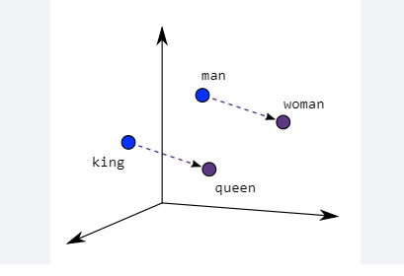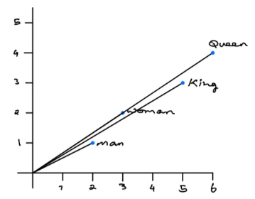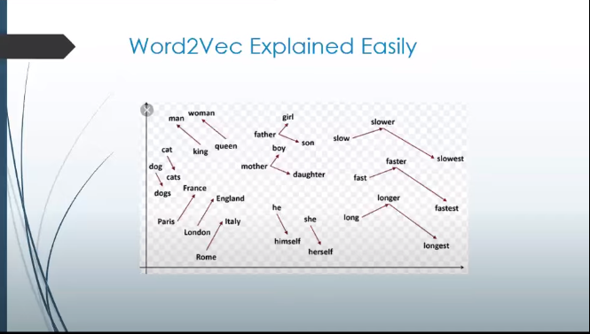

CBOW (Continuous Bag of Words)
This architecture is very similar to a feed forward neural network. This model architecture essentially tries to predict a target word from a list of context words. The intuition behind this model is quite simple: given a phrase "Have a great day" , we will choose our target word to be “a” and our context words to be [“have”, “great”, “day”]. What this model will do is take the distributed representations of the context words to try and predict the target word.
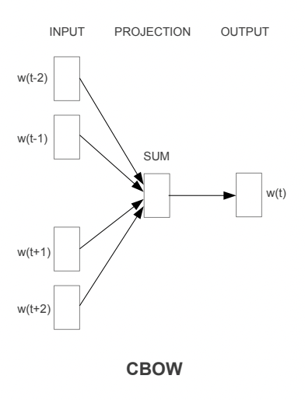

SKIPGRAM

1.2) Skip Gram
In this model, we try to make the central word closer to the neighboring words. It is the complete opposite of the CBOW model. It is shown that this method produces more meaningful embeddings.
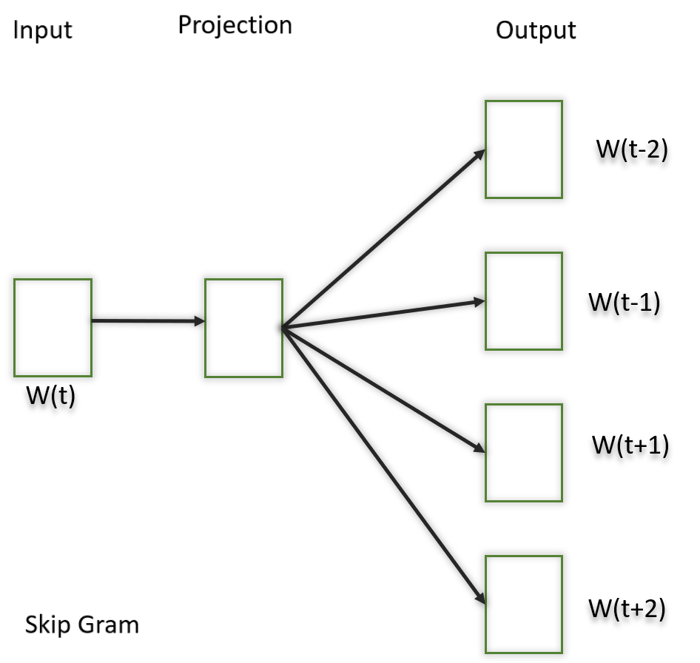

Word2Vec only captures the local context of words. During training, it only considers neighboring words to capture the context. GloVe considers the entire corpus and creates a large matrix that can capture the co-occurrence of words within the corpus.

GLOVE--Global Vectors for Word RepresentatioN
It leverages both
- Global matrix factorization methods like latent semantic analysis (LSA) for generating low-dimensional word representations
- Local context window methods such as the skip-gram model of Mikolov et al

What is GloVe?--unsupervided
GloVe stands for global vectors for word representation. It is an unsupervised learning algorithm developed by Stanford for generating word embeddings by aggregating global word-word co-occurrence matrix from a corpus. The resulting embeddings show interesting linear substructures of the word in vector space.
